

FOSSASAT-2 Solar Cell & Sun Sensor Characterization

Characterization Intended for the configuration of the in-orbit ADS System for establishing a point of reference to the sun.

**FOSSA Systems**

**Julian Fernandez Barcellona**

May 2020

# Preamble

This brief report is intended to document and analyse the solar dependent attitude determination system of the FOSSASAT-2 spacecraft in order to interpret a relative orientation to the sun. Basic equations and relationships are established in order to correlate a solar angle of incidence on each sensor to a current and lux readings.

Contents

Preamble 2

Table of Figures 3

1. FOSSASAT-2 Sun Sensing External Design & Placement 4

1.1. Coordinate System 4

1.2. Panel Configuration 5

1.3. Sun Sensor Placement & Obstructions 5

2. Solar Sensor Device Characterization 6

2.1. IXYS Solar Cells 6

2.2. VEML7700 Light Sensors 9

# Table of Figures

Figure 1 - External Coordinate System 4

Figure 2 - External Coordinate System 2 5

Figure 3 - Antenna Sunlight Obstruction 6

Figure 4 – Solar Panel Generated Power vs Temperature of Solar Cells 7

Figure 5 – Solar Panel Generated Power vs Angle of Incidence 8

Figure 6 – Y- Face Generated Power vs Angle of Incidence 9

Figure 7 -VEML7700 Generated Power vs Angle of Incidence 10

# FOSSASAT-2 Sun Sensing External Design & Placement

## Coordinate System

The coordinate system used to reference each axis is as shown in the drawings below:

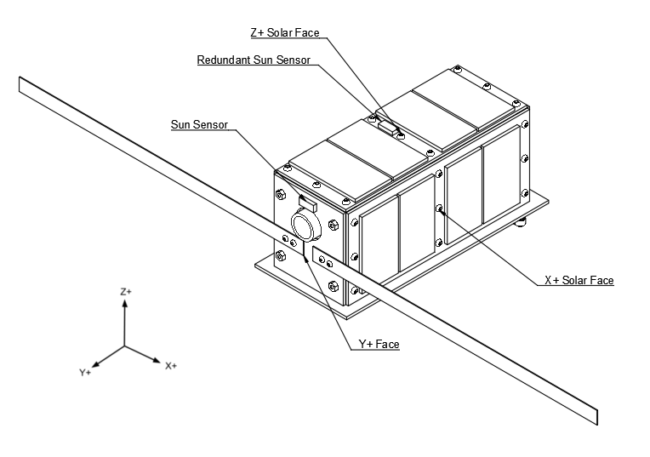

Figure 1 - External Coordinate System

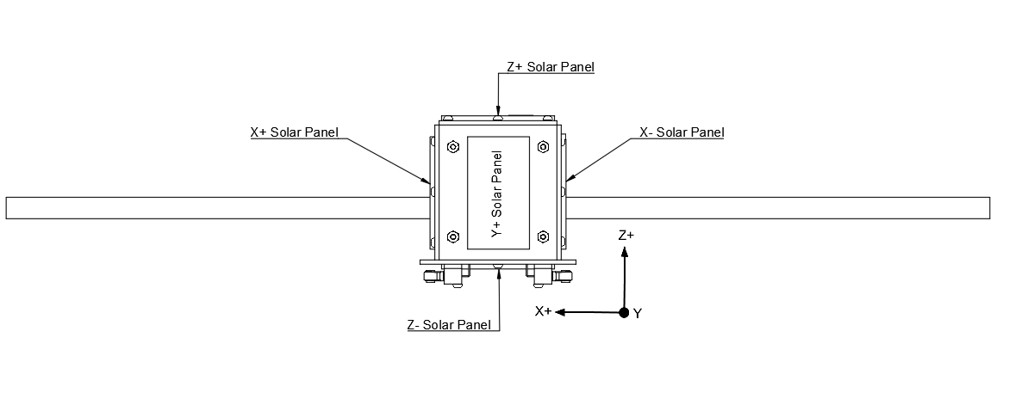

Figure 2 - External Coordinate System 2

## Panel Configuration

Each face has the following configuration:

* X+ Face: 4 IXYS SM141K06L Solar Cells
* X- Face: 4 IXYS SM141K06L Solar Cells
* Y+ Face: 1 VEML7700 Light Sensor & Camera (Earth Pointing / NADIR)
* Y- Face: 1 IXYS SM141K06L Solar Cells
* Z+ Face: 4 IXYS SM141K06L Solar Cells & 1 VEML7700 Light Sensor
* Z- Face: 4 IXYS SM141K06L Solar Cells

As such, all faces have a sun sensing device of some sort. In addition, the Z+ axis features a redundant sun sensing device which can be used but is not essential.

## Sun Sensor Placement & Obstructions

All solar panels are placed in a near centrical or symmetrical manner, likewise, the light sensors can be considered as being in a near centre position on each face for the sake of simplicity.

**Obstructions**

No major obstructions occur on any sun sensors that could cause a variation greater than that of the standard variation of the sensor in normal operation, X+ and X- panels are an exception to this.

**Antenna**

The antenna has a width of 10mm and extends 150mm from the Y+ Face in the X+ and X- direction as seen in the drawing.

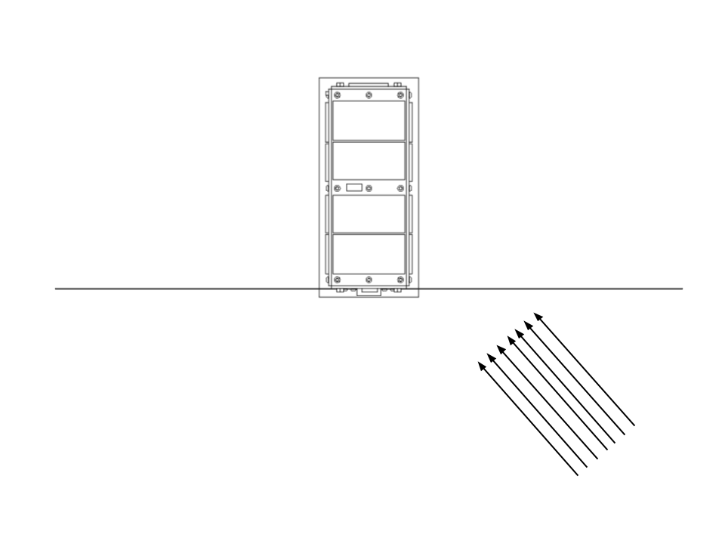

Figure 3 - Antenna Sunlight Obstruction

This obstruction only has a significant effect once the light source already has an angle of incidence on the Y+ Solar Sensor. A basic calculation in a worst-case scenario dictates the that this would reduce the surface area and thus the total power of either the X+ or X- panel 23% only, this also “starts” to occur in under 3% of all possible orientations. This thus can be ignored for the sake of simplicity.

# Solar Sensor Device Characterization

## IXYS Solar Cells

The solar cells have the following characteristics measured at 1000W/m2:

|  |  |  |  |
| --- | --- | --- | --- |
| Part Number | Open Voltage (V) | Short Circuit Current (mA) | Current at MPP (mA) |
| SM141K06L | 4.15 | 58.6 | 55.1 |
| Maximum peak power (mW) | open circuit voltage temp. coefficient (mV/K) | max power temp. coefficient (uA/K) | solar cell efficiency  (%) |
| 184 | -10.4 | 26.5 | 25 |

**Temperature Variation**

Considering temperature variation of the solar panel, calculations show that a maximum variation of +/- 10% of the total power is expected in the system given the current thermal model. In any case, this heat variation mostly affects the system in an equal manner and therefore mostly cancels out.

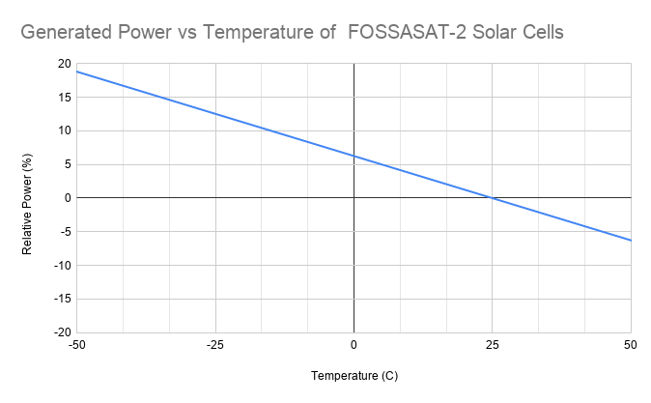

Figure 4 – Solar Panel Generated Power vs Temperature of Solar Cells

The approximate relative power equation where $t=temperature in celsius$ therefore is:

$$f\left(t\right)= -0.25(273+t)+74.5$$

FOSSASAT-2 has various temperature sensors to take this Is consideration, but the effect is considered null.

**Actual Power vs Angle of Incidence**

Power generated by each solar panel has the following relationship to angle of incidence:

$$P_{F}=P_{I}\cos{α}$$

Where:

$α$ = Angle of incidence (In any direction above the cell’s horizon: 0º-90º)

$P_{F}$ = Generated Power at $α$ angle in mW

$P_{I}$ = MPP Current * MPP Voltage at $α$ angle of 0 in mW

Each solar panel has an individual INA260 current and voltage sensor. Since the exact power generated by a solar panel is not able to be calculated on the ground, the system will need to take $P_{F}$ as the highest power recorded (considering it as direct sunlight) and then compare it to the current generate power. The system will be preloaded with estimates that will be calculated in the next section; however, it is wiser to implement a system that then compares it to the maximum power.

**For the X+, X-, Y+ and Y- Solar panels**, the following estimations are made:

Considering an increased irradiance of 1366 W/m2 as opposed to 1000W/m2  on earth and a near constant efficiency at this high irradiance, a multiplication of 1.33 of the obtained power can be made.

MPP Current * MPP Voltage * Cells = Total MPP Power

Considering a voltage drop of 50mV due to the MAX40200 Idea diodes.

4 cells = 55.1mA * (3.35V – 0.05V) * 4 cells = 727mW

MPP Power * 1.33 = 967mW

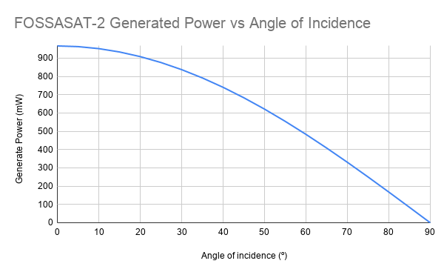

Figure 5 – Solar Panel Generated Power vs Angle of Incidence

Therefore, the maximum estimated power for the X+, X-, Y+ and Y- Solar panels with an angle of incidence 0º is 967mW.

**For the Y- Solar panel**, the same calculation is carried out but 1 cell is used instead of 4.

The maximum estimated power for the X+, X-, Y+ and Y- Solar panels with an angle of incidence 0º is 242mW.

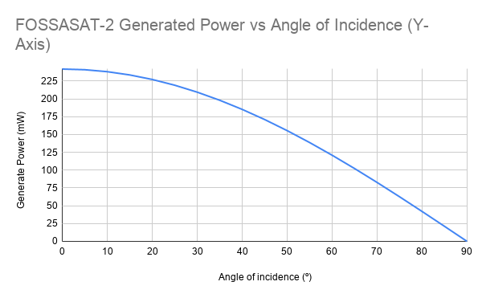

Figure 6 – Y- Face Generated Power vs Angle of Incidence

It is important to note that the solar cells have a certain inaccuracy when it comes to predicting the angle due to their not exactly linear response. Furthermore, the albedo of the earth is approximately 37%-39%. This should not lead to major confusion considering that a worst-case scenario at 45º would have a Cos45 = (70% of Sunlight Irradiance).

## VEML7700 Light Sensors

The VEML7700 Sun sensor has a rated range of approximately 0-120k lux with a +/- 10% uncertainty compared to a calibrated sun sensor; this range however is extended to 180klux by having a higher uncertainty of a +/- 20% compared to a calibrated sun sensor.

Similarly, to the solar panels:

Measured lux on the sensor has the following relationship to angle of incidence:

$${LX}_{F}={LX}_{I}\cos{α}$$

Where:

$α$ = Angle of incidence (In any direction above the sensor’s horizon: 0º-90º)

${LX}_{F}$ = Measured Lux at $α$ angle

${LX}_{I}$ = Measured Lux at angle of 0º

Once again, Since the exact lux measured is not able to be calculated on the ground, the system will need to take ${LX}_{F}$ as the highest level recorded (considering it as direct sunlight) and then compare it to the current lux reading. The system will be preloaded with estimates that will be calculated in the next section; however, it is wiser to implement a system that then compares it to the maximum power.

Considering an approximate conversion of 0.0079W/m2 per lux for sunlight, 172911 lux is the maximum expected value at an angle of incidence of 0º. It is also important to consider that the greater the intensity of the light, the higher uncertainty we have on the angle. This should not be an issue considering the satellite should only require minimum precision when pointing NADIR, thus this sensor is not used.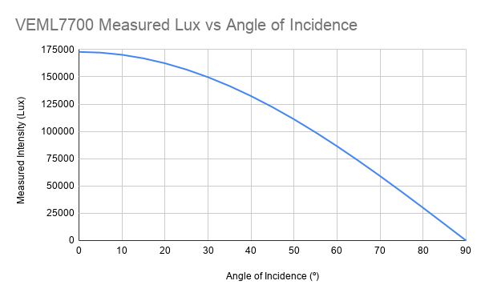

Figure 7 -VEML7700 Generated Power vs Angle of Incidence